AGENCIA DE _____________

APRIL 17th, 2013
Present
_________________
TO WHOM IT MAY CONCERN

DEAR:

By this document we request references about one of your customer or supplier ______________- S.A. DE C.V. Because we’ll verify the information that was provided by the investigated.
YOUR COMPANY NAME:
ADDRESS:
TELEPHONE NUMBER:
HOW LONG DO YOU KNOW THEM?
NAME OF PERSON PROVIDING INFORMATION:
YOUR POSITION:

ARE THEY YOUR | CUSTOMER? |  |  |  |  | SUPPLIER?
WHAT PRODUCTS OR SERVICES DO YOU BUY/SELL TO THEM?
THEIR CREDIT’S LIMIT: |  | CASH |  | OPEN |  |  | MAXIMUM:
MONTHLY SALE’S AVERAGE: |  |  |  |  |  | TERM TO PAY

DO THEY PAY YOU ON TIME? | YES | NO | DO YOU RECOMMENDABLE OUR INVESTIGATE? | YES | NO
WHY?
ANOTHER OPINION ABOUT YOUR CUSTOMER/SUPPLIER?
Your prompt response to this request would be greatly appreciating it. Should you have any questions or comments please feel free to contact me. Thank you very much for you cooperation

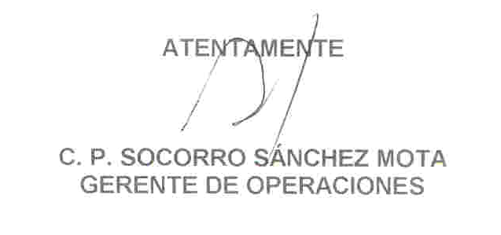

TEL. AND FAX: +52 (55) 1999-8640 E-mail:informescib@ciasc.mx

